
QUALITY ALERT

Customer: Vision Coating - Golden Date: February 7, 2024
Die: 15602 Colour: ALL
Type of Complaint: Vision Coating REJECTED

Q.A # Q.I.R # CUSTOMER NCR #

Description: Customer REJECTED due to material have extra vinyl thread affecting the painting process.
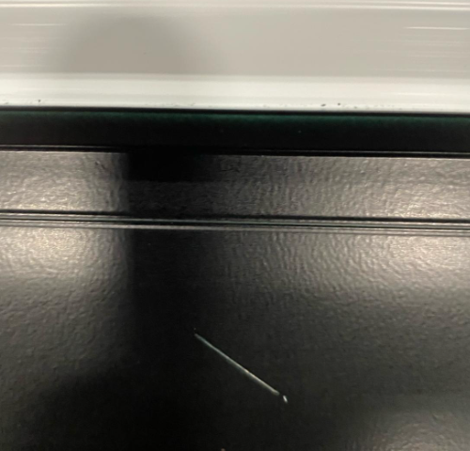
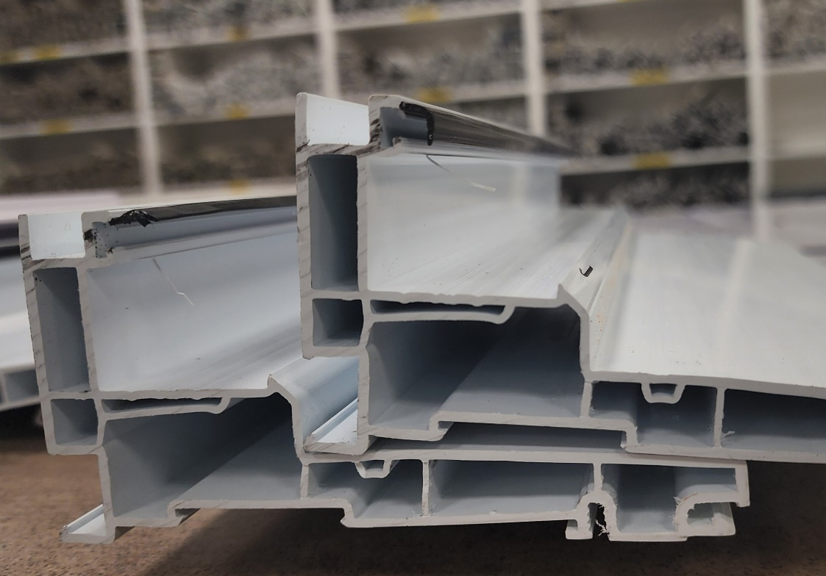

PLEASE MAKE SURE DO NOT HAVE ANY EXTRA VINYL
APPLY ALL GOLDEN MATERIAL

BY SIGNING BELOW, YOU ACKNOWLEDGE THE PROBLEM ABOVE AND AGREE TO MONITOR THIS ISSUE IN FUTURE PRODUCTION RUNS.
DAY SHIFT |  | AFTERNOON SHIFT |  | NIGHT SHIFT
NAME | SIGNATURE | NAME | SIGNATURE | NAME | SIGNATURE

